Assignment 5

Part II

1. Build and Run Docker
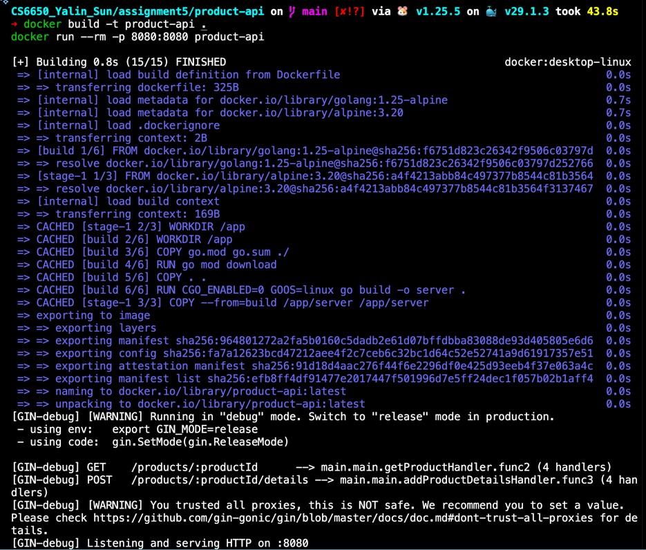

2. Test the API
(1) Test GET - 200 OK
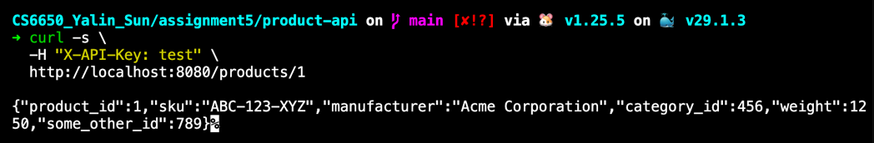

(2) Test GET – 404 Not Found
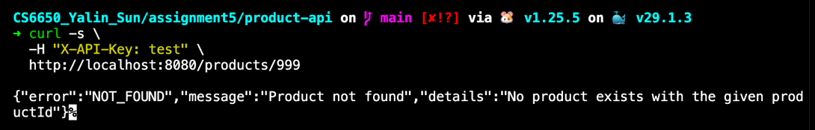

(3) Test POST – 204 Success
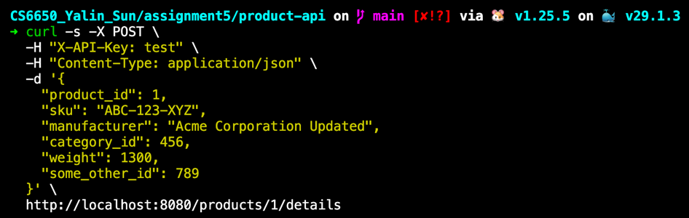
(4) Test POST – 400 Invalid Input
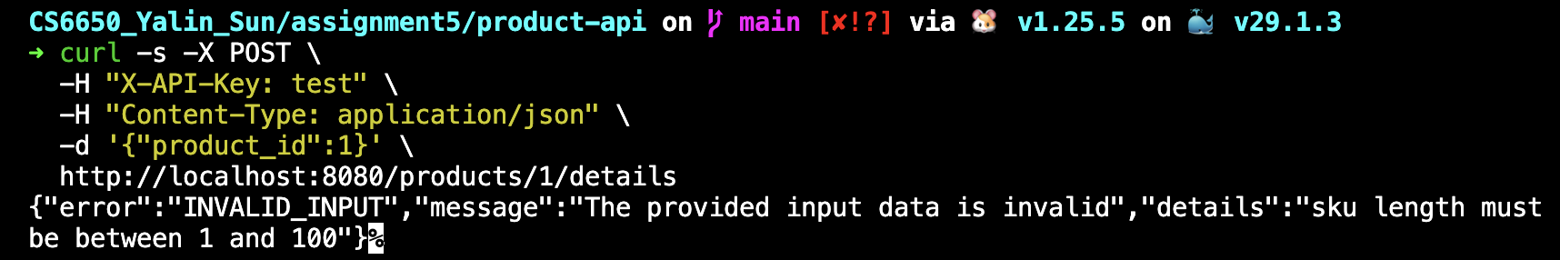

(5) Test POST – 401 Unauthorized

Part III

1. Terraform init/apply
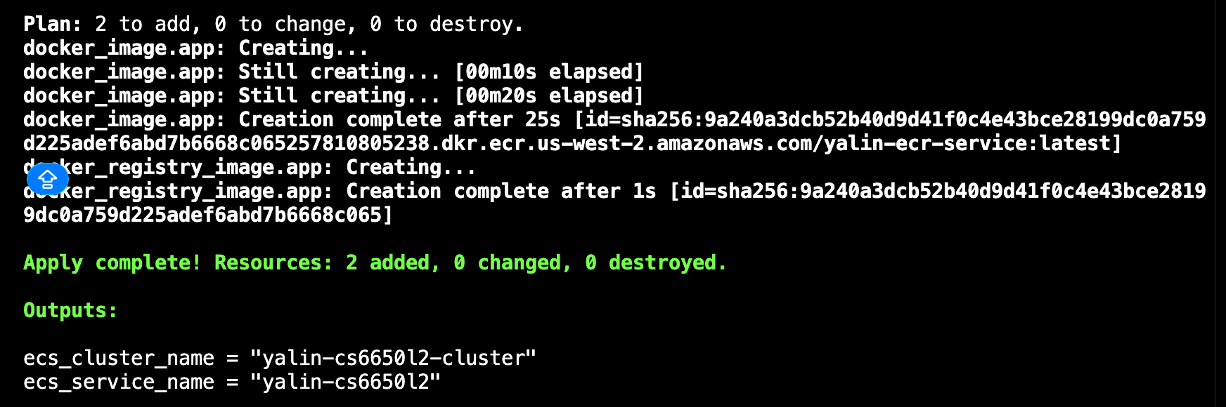

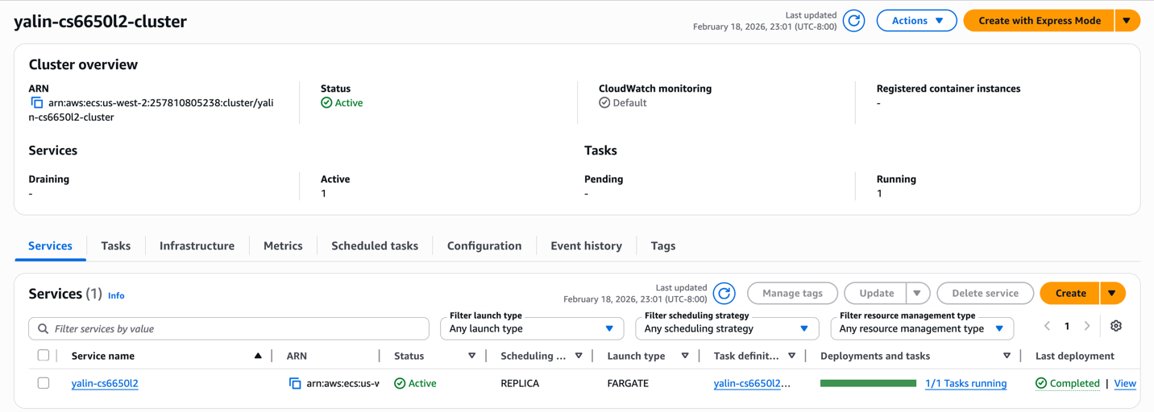

2. Test
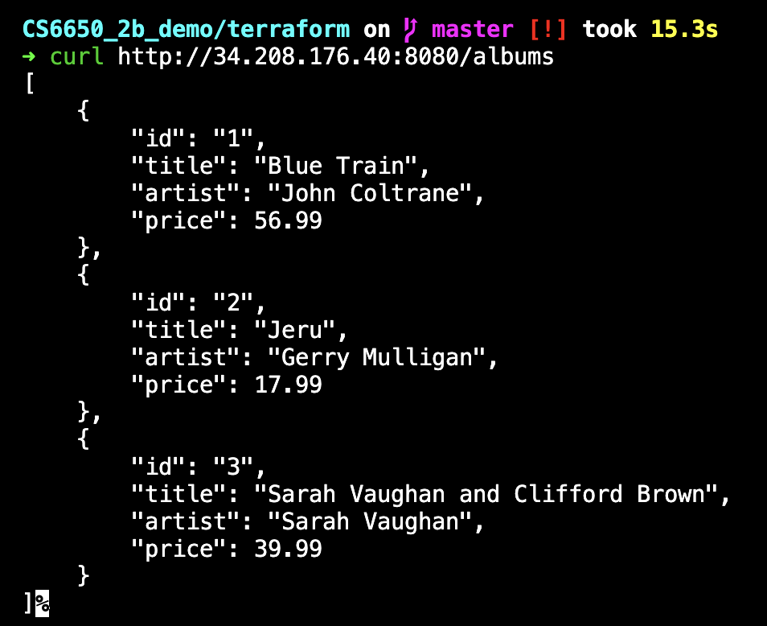

3. Deploy Product-API use the same way
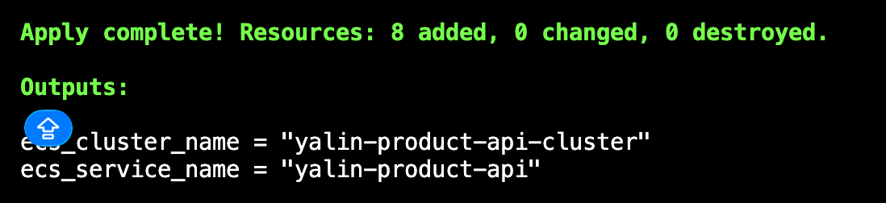

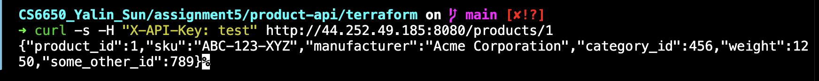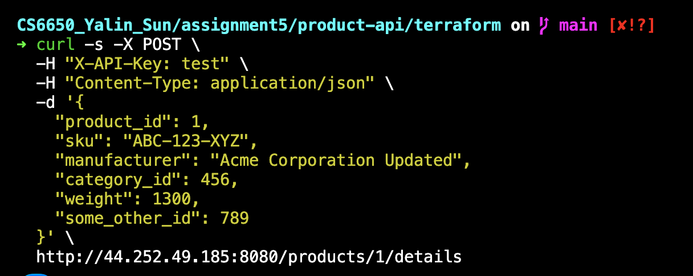

Part IV

1. Test 1 (baseline)

Parameters:
Users: 50
Spawn rate: 10 users / second
Workers: 1
User class: HttpUser
GET:POST: 3 : 1

Results:
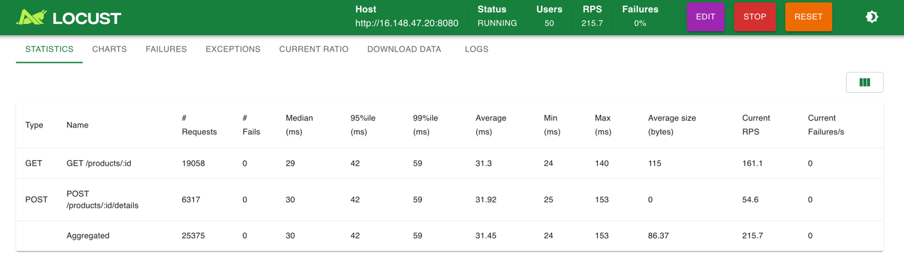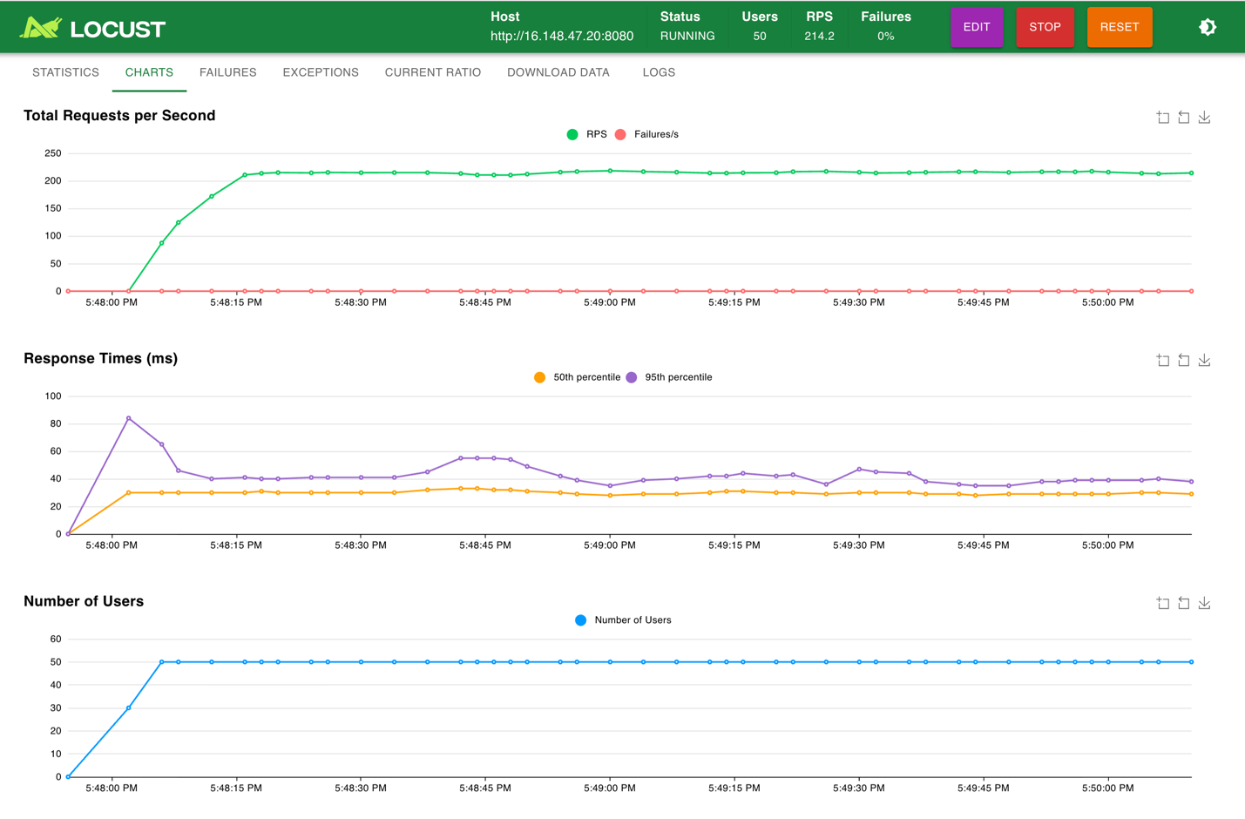

Analysis:
the system achieved a stable throughput of approximately 210–216 requests per second (RPS). GET requests achieved a higher throughput (≈161 RPS) compared to POST requests (≈55 RPS), which is expected since GET operations only require read access to the in-memory store, while POST operations involve write access and additional synchronization overhead.
Latency remained stable throughout the test. The median response time for both GET and POST requests was approximately 28–30 ms, while the 95th percentile latency mostly in the 35–45 ms range, indicating consistent performance under load. No significant latency spikes were observed after the ramp-up phase, suggesting that the system reached a steady state once all users were active.
Overall, this baseline experiment demonstrates that the system can handle moderate concurrent load efficiently with low latency and no request failures when operating under expected conditions. These results provide a solid reference point for subsequent experiments involving higher concurrency, multiple workers, and alternative user implementations.

2. Test 2
Parameters:
Users: 50
Spawn rate: 10 users / second
Workers: 4
User class: HttpUser
GET:POST: 3 : 1

Results：

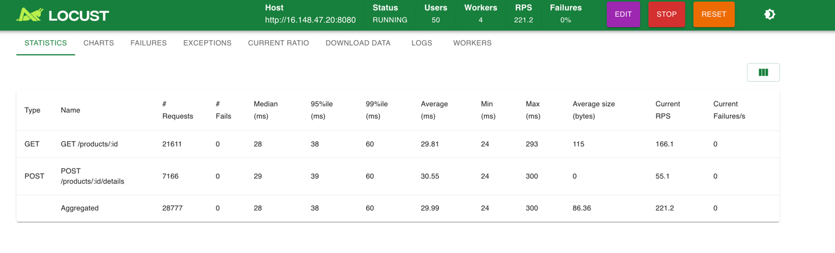
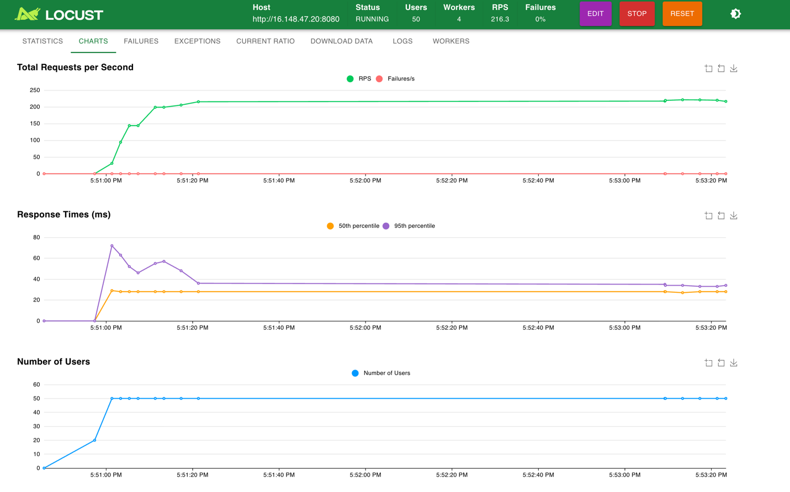

Analysis

When increasing the number of Locust workers from 1 to 4, the overall system throughput does not scale linearly. The observed RPS remains in the range of 215–220 requests per second, which is very close to the baseline result. This suggests that the load generation capacity was already sufficient with one worker and that the system is now limited by the server rather than the client-side load generator.

Response times show a small increase compared to the baseline. The median latency increases slightly to around 29–30 ms, and the 95th percentile rises to approximately 55–60 ms. The latency curves remain stable after the ramp-up period, and there are still no request failures, indicating that the system remains reliable under the same user load.

GET and POST latency patterns remain consistent with the baseline: GET requests are marginally faster than POST requests due to the difference between read locks and write locks on the shared in-memory data structure.

The lack of significant throughput improvement with additional workers illustrates Amdahl’s Law in practice. Although the load generator can scale horizontally, the server contains a serial bottleneck: access to the shared in-memory map protected by a mutex. Write operations, in particular, require exclusive access and limit how much concurrency can be exploited.

3. Test 3

Parameters:
Users: 50
Spawn rate: 10 users / second
Workers: 1
User class: FastHttpUser
GET:POST: 3 : 1

Results
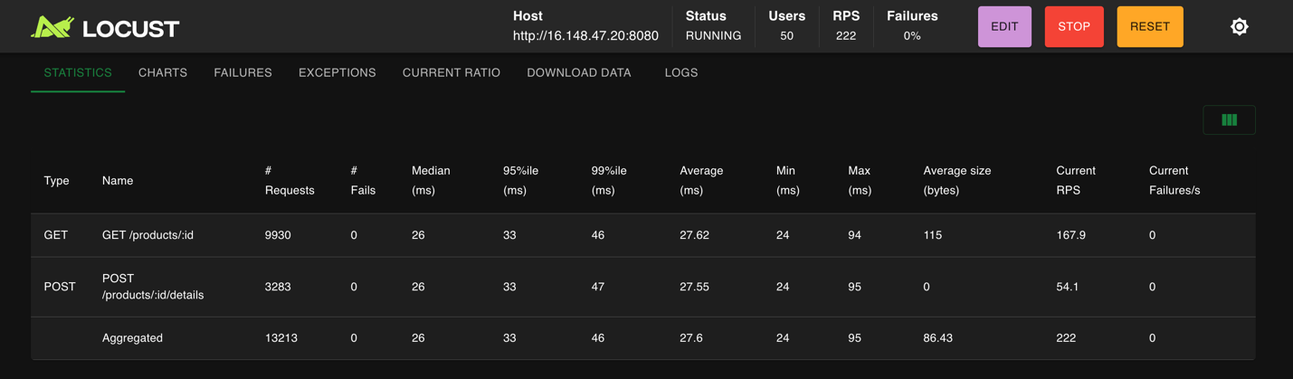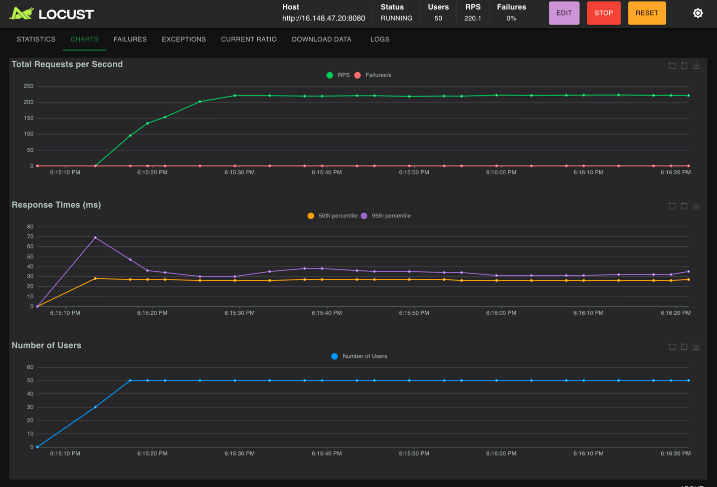

Parameters:
Users: 50
Spawn rate: 10 users / second
Workers: 4
User class: FastHttpUser
GET:POST: 3 : 1

Results:
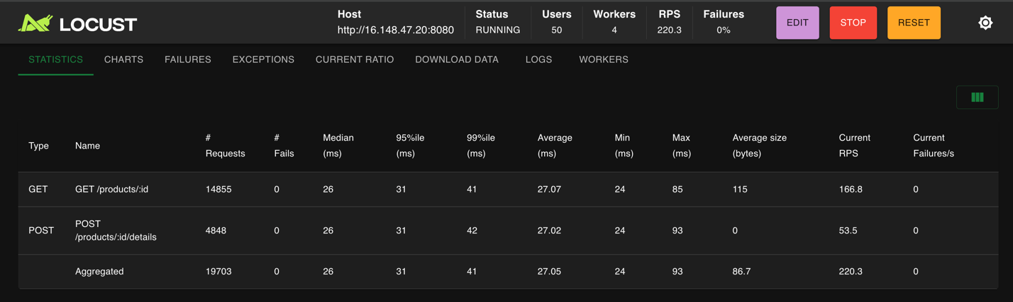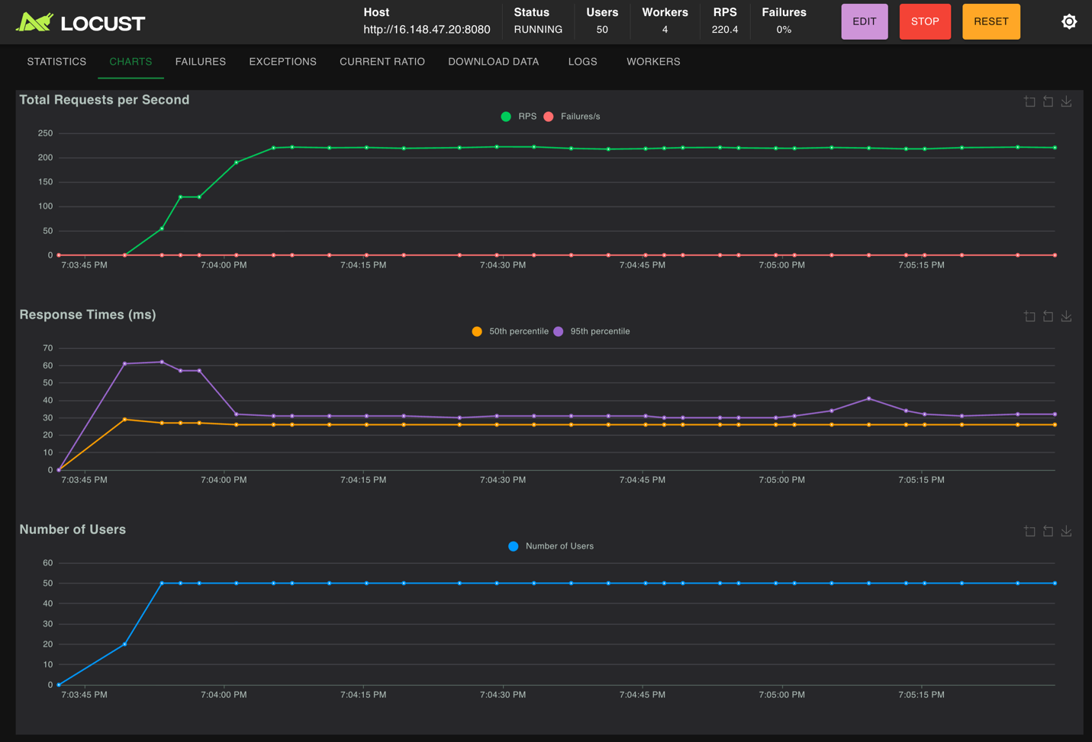

Analysis：

In Test 3, I evaluated the impact of increasing the number of Locust workers when using the FastHttpUser, which is designed to reduce Python-level overhead and context switching. Both experiments used identical parameters: 50 users, a spawn rate of 10 users per second, and a GET:POST ratio of 3:1. The only difference between the two runs was the number of workers (1 vs. 4).

With 1 worker, the system reached a stable throughput of approximately 220 RPS after the ramp-up phase. The median response time stabilized around 26–27 ms, and the 95th percentile remained mostly below 40 ms after the initial spike during user ramp-up. No request failures were observed, indicating the system handled the load reliably.

When increasing to 4 workers, overall throughput remained very similar, again stabilizing around 220 RPS. Response-time metrics also showed minimal change: the median latency stayed around 26 ms, and the 95th percentile was slightly lower and more stable compared to the single-worker case. Importantly, failures remained at 0%, and the response-time curves appeared smoother after the ramp-up period.

Overall, the results show that adding more workers did not significantly increase throughput when using FastHttpUser. This suggests that the workload was already saturating another bottleneck—most likely the application server or available CPU—rather than the Locust worker itself. However, the multi-worker setup slightly reduced response-time variance, indicating that additional workers can help smooth scheduling and context switching overhead even when they do not improve peak throughput.

4. Test 4 (Stress Test)

Parameters:
Users: 200
Spawn rate: 20 users / second
Workers: 4
User class: FastHttpUser
GET:POST: 3 : 1

Results:
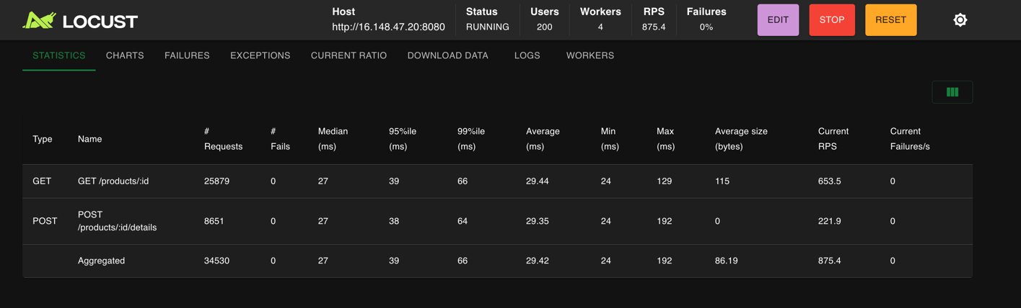
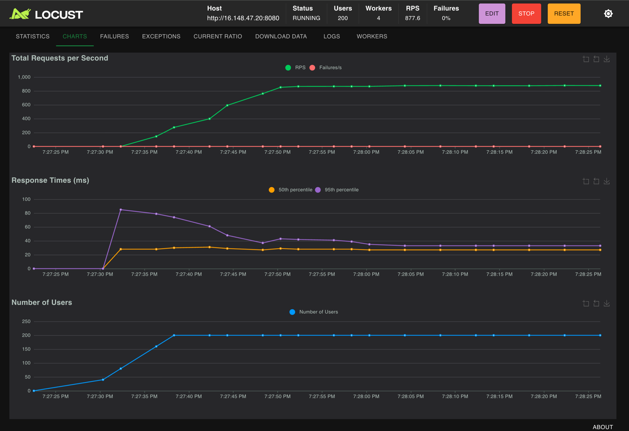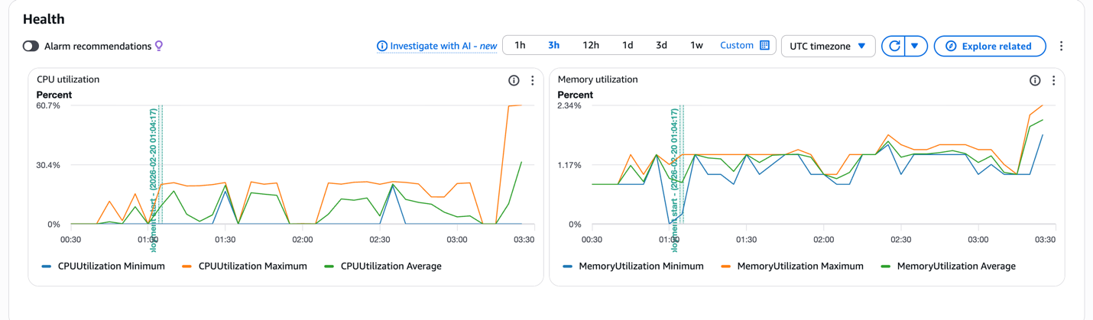

Parameters:
Users: 300 / 400
Spawn rate: 20 users / second
Workers: 4
User class: FastHttpUser
GET:POST: 3 : 1

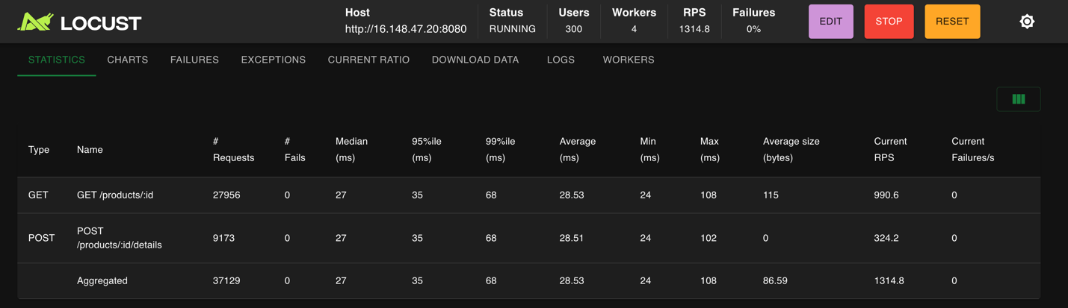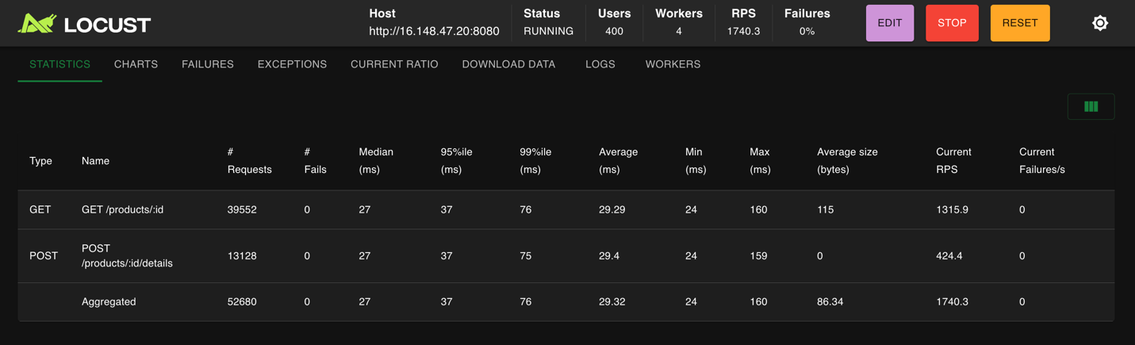

In this experiment, I conducted an extended stress test to evaluate the scalability and stability of the service under increasing load. The test used the FastHttpUser class with a fixed request mix of GET:POST = 3:1, a spawn rate of 20 users per second, and 4 Locust workers. I progressively increased the number of concurrent users from 200 to 300 and then to 400.
Across all three load levels, the system demonstrated strong and consistent performance. As the number of users increased, the total throughput scaled almost linearly: approximately 875 RPS at 200 users, 1315 RPS at 300 users, and 1740 RPS at 400 users. This indicates that the system was not yet saturated and was able to effectively utilize additional concurrency.
Latency remained stable throughout the tests. The median response time stayed around 27–29 ms, while the 95th and 99th percentile latencies increased only moderately as load increased (P99 rose from ~66 ms at 200 users to ~76 ms at 400 users). Importantly, there was no sudden spike or “tail latency explosion,” which suggests that request queuing and server-side contention were well controlled under these workloads.
No request failures were observed at any load level, and the failure rate remained at 0%. CPU utilization metrics showed moderate usage without sustained saturation, and memory usage remained low and stable. This confirms that the system was not constrained by CPU or memory resources during the test window.
Overall, these results indicate that the service has a high performance ceiling relative to the tested workload. Rather than exposing a breaking point, the stress test demonstrates that the system scales efficiently with increased concurrency and maintains low latency under heavy load. This suggests that the current bottleneck lies beyond 400 concurrent users or that additional constraints (such as higher spawn rates, reduced wait times, or artificial server-side delays) would be required to push the system into a failure or saturation regime.

